User Assistance Documentation Retrieval – Observation Report

This document summarizes the analysis performed on the UA Documentation Retrieval tool within the Integrated Engineering Collaboration domain (ICELB).

Summary
Query No. | Expected Document to be Retrieved | User Query | Observation Summary | Conclusion
Query1 | Adding a Member to an Extended Collaboration | How to add a member to the team of extended collaboration | Correct document retrieved with highest similarity score (43.67). Content is fully relevant and complete. | Accurate and complete retrieval
Query2 | About an Extended Collaboration Members | List out all the responsibilities of Extended Collaboration Administrator, Leading Team, and Partner Team | Content retrieved in multiple chunks with different similarity score (73.58, 1.80) First chunk covers Administrator & Leading Team responsibilities; second chunk contains Partner Team info with low similarity score. But together they form a complete answer. | The system correctly retrieves the document but splits relevant content into separate chunks, leading to variation in similarity scores.
Query3 | Deactivating and Reactivating an Extended Collaboration | How to reactivate an extended collaboration | Document retrieved in two chunks with different similarity scores (28.86, 36.76). Chunk 1 contains info about reactivation steps (fully relevant), Chunk 2 contains deactivation + partial reactivation info (highest similarity score but partially irrelevant) | Correct document retrieved but split into chunks; fully relevant information is obtained only when both chunks are considered. Even though the first chunk contains more relevant info about the user query it has low similarity score than chunk 2.
Query4 | About the Extended Collaboration Dashboard and Access to Content | What are the functionalities available in the Collaborate tab of the Extended Collaboration Dashboard? | Correct document retrieved, but only partial relevant content is retrieved. Key information about the query is missing. | Fails to retrieve complete and relevant content for the given query.
Query5 | Creating an Extended Collaboration | How to create an extended collaboration between leading team and one or several partner team. How to initiate the creation from home page? | Correct document retrieved with high similarity score (125.66). But out of 9 steps Only Steps 1–5 retrieved;  remaining Steps  6–9 is missing. | Retrieval is incomplete despite high relevance score. Fails to retrieve complete and relevant content for the given query.

Query 1:
“How to add a member to the team of extended collaboration”
Expected Result:
- Relevant document: Adding a Member to an Extended Collaboration

Observations:
- The system correctly retrieved the relevant document with Similarity Score: 43.67 (highest)

Conclusion: Retrieval is accurate and relevant for this query.

Query 2:
“List out all the responsibilities of Extended Collaboration Administrator, Leading Team, and Partner Team”
Expected Result:
- Relevant document: About the Extended Collaboration Members
Observations:
- The system retrieved this document twice, by splitting the content into two chunks:
Result
Retrieval | Similarity Score | Content Covered | Observation
1 | 73.58 | Document covering Administrator and Leading Team responsibilities and partial info about partner team | Correct and relevant content for Administrator and Leading Team retrieved
2 | 1.80 | document covering rest of the info about Partner Team responsibilities | Low similarity score; relevant content; Partner Team info separated from Administrator/Leading Team content

Conclusion: The system correctly retrieves the document but splits relevant content into separate chunks Full information is obtained only when both chunks are considered, leading to incomplete coverage in a single chunk and variation in similarity scores.

Query 3:
“How to reactivate an extended collaboration”
Expected Result:
- Relevant document: Deactivating and Reactivating an Extended Collaboration
Observations:
- The system retrieved this document twice, by splitting the content into two chunks with different similarity score.

Result
Retrieval | Similarity Score | Content Covered | Observation
1 | 28.86 | Contains only reactivation steps and relevant information for the query | Fully relevant to the user query.
2 | 36.76 | Contains deactivation information + partial reactivation | Has the highest similarity score, but includes irrelevant content (deactivation) and only partial reactivation information.

Conclusion: The system correctly retrieves the document but splits relevant content into separate chunks Full information is obtained only when both chunks are considered, leading to incomplete coverage in a single chunk and variation in similarity scores. Even though the first chunk contains the most relevant information for the user query, its similarity score (28.86) is lower than chunk 2 (36.76).

Query 4:
“What are the functionalities available in the Collaborate tab of the Extended Collaboration Dashboard?”

Expected Result
The system should retrieve:
- The document relevant to the user query i.e. (About the Extended Collaboration Dashboard and Access to Content) and the content URL is User Assistance R428rel/English
- Content specifically related to the Collaborate Tab
- And should retrieve all the content and subsections related to the collaborate tab they are,
  - 3DSwym
  - Project Planning
  - Bookmark Editor
Observations:
- When I run the query, the total responses retrieved is around 15 chunks which are mapping to different documents.
  - Among 15 chunks the 4 chunks belonged to the correct document “About the Extended Collaboration Dashboard and Access to Content” however, they had different similarity scores.
- Even though the correct document was retrieved:
  - The most relevant information was missing
  - Retrieved chunks did not fully cover the Collaborate Tab
Result:
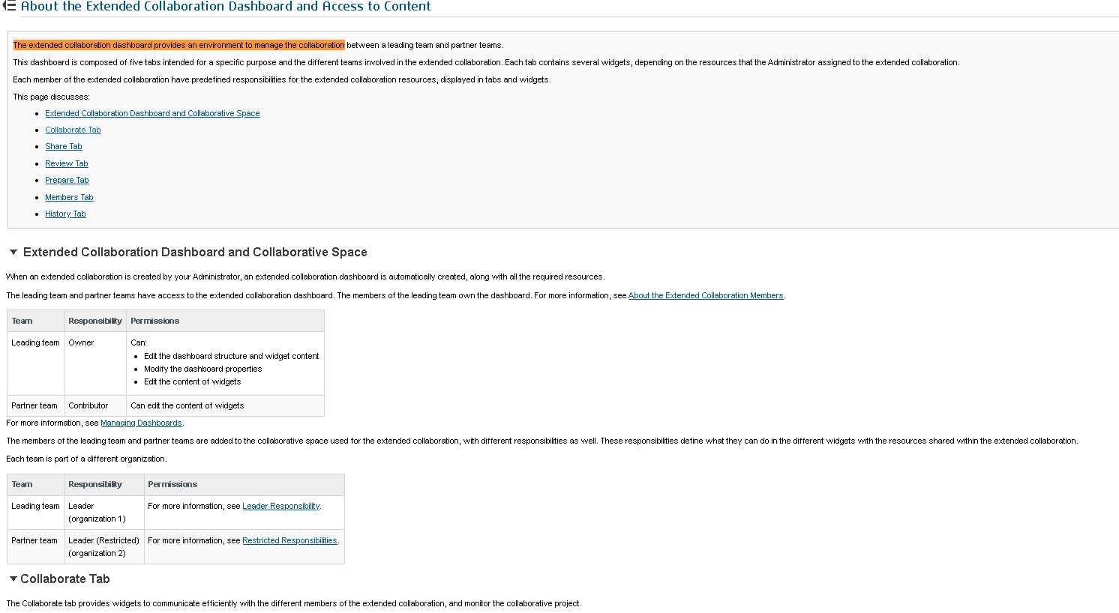
Chunk 1: It is referring to the exact document where the relevant information to the user query is present.
- Similarity Score: 47.61 (Highest)
- Content Covered: Beginning of the document up to the start of the Collaborate Tab
- Observation: Does not include any subsections of the Collaborate Tab

We expect that the next chunk which maps to the same document should retrieve the data from collaborate tab. But,
- Chunk 2: refers to the same document with,
- Similarity Score: 1.80
- Content Covered: Prepare Tab to partial Members Tab
- Observation: Content is not relevant to the query (Focus is outside the Collaborate Tab)
- Actually we are focusing on only collaborate tab since the query is about collaborate tab. But this chunk retrieved the info about prepare tab (seems irrelevant).
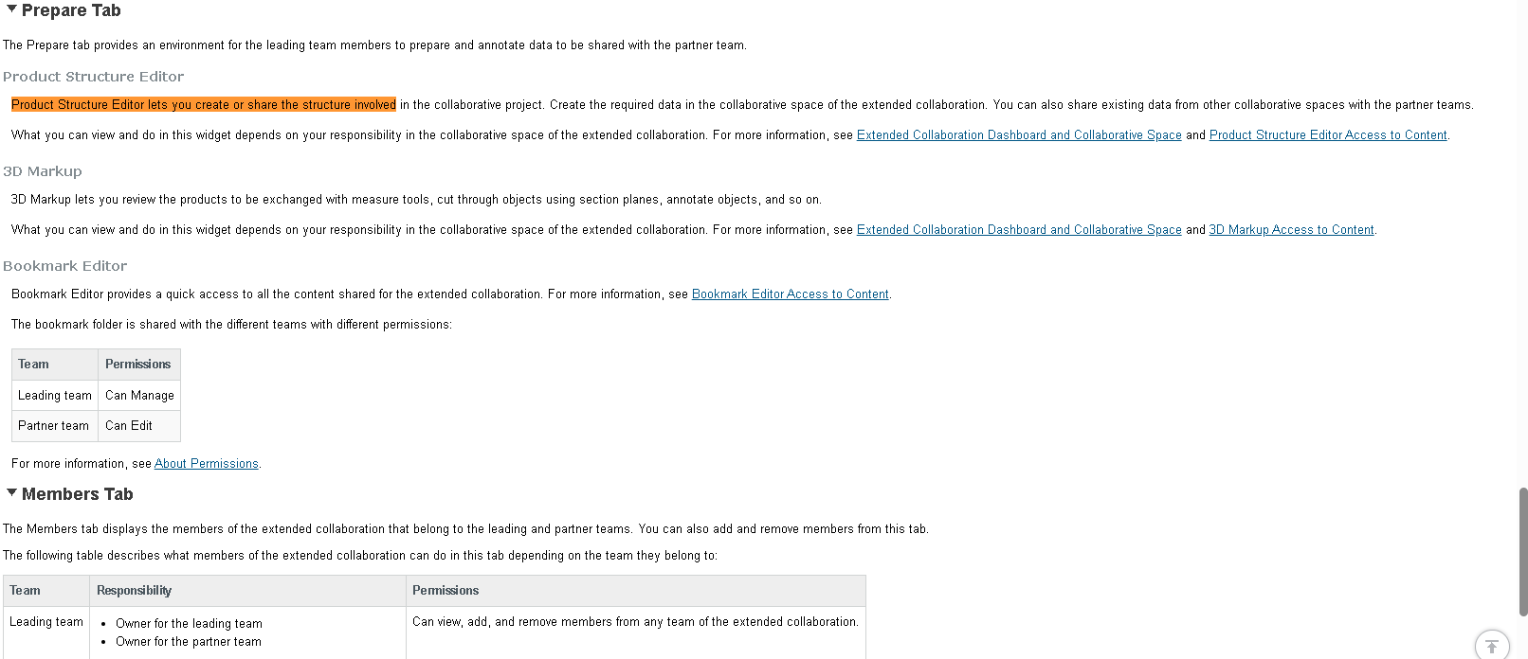

- Chunk 3: this chunk maps to the same document with,
- Similarity Score: 1.79
- Content Covered: Bookmark Editor (subsection of Collaborate Tab) to Share Tab
- Observation: Contains partial relevant information (Only one subsection Bookmark Editor is retrieved)
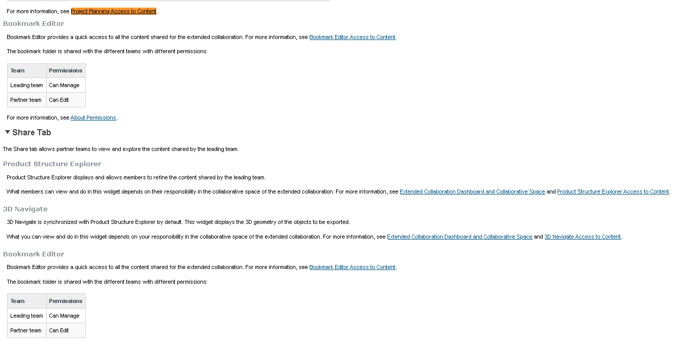

- Chunk 4: this chunk maps to the same document with,
- Similarity Score: 1.78
- Content Covered: Members Tab to History Tab (end of document)
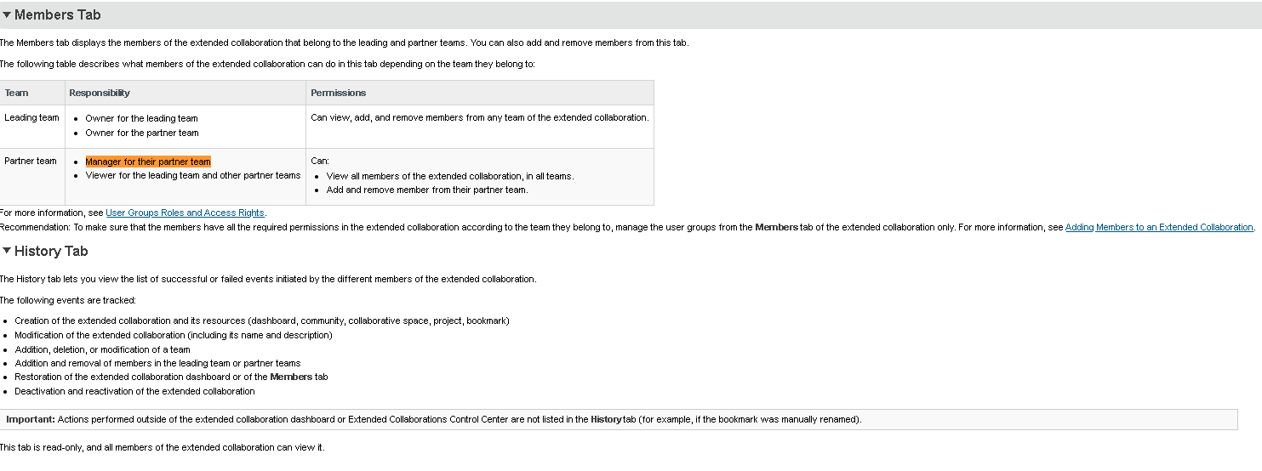
- Observation: Completely irrelevant to the query (not retrieved info about collaborate tab)

Note:
- Here the query is completely focusing on Collaborate Tab but the important information about the collaborate tab is missing.
- The system missed key subsections of the Collaborate Tab:
3DSwym
Project Planning
Only partial content of the collaborate tab was retrieved that is:
Bookmark Editor

Conclusion: The system is able to identify and retrieve the correct document. However, it fails to retrieve complete and relevant content for the given query.

Query 5:
“I need detailed instructions on how to create an extended collaboration between a leading team and one or several partner teams involved in a collaborative project. Specifically, I want to know: How to initiate the creation of an extended collaboration from the home page.”
Expected Result:
- Relevant document: Creating an Extended Collaboration
- Complete step-by-step instructions (all 9 steps) for creating an extended collaboration should be retrieved
Observations:
- The system retrieved the correct document: Creating an Extended Collaboration
- The document was retrieved twice, with a high similarity score: 125.66
- However, the retrieved chunks only covered:
  - Steps 1 to 5 of the process

Result
Retrieval | Similarity Score | Content Covered | Observation
1 | 125.66 | Steps 1–5 | Highly relevant but retrieved partial result.
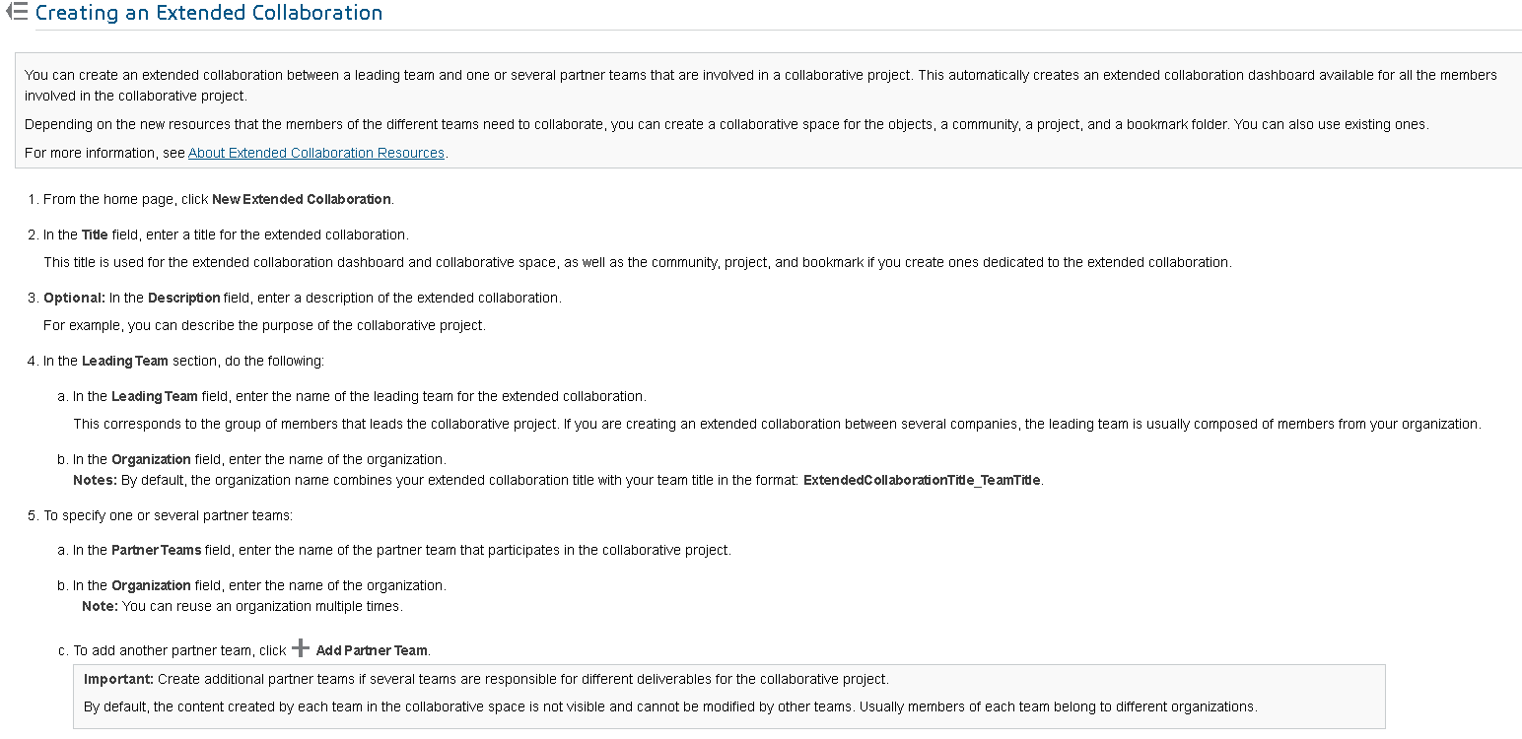

Chunk 2 : Retrieved the content present after 9 steps (end of document) by skipping the required content from step 6-9.
The content retrieved by the chunk 2 is not relevant.
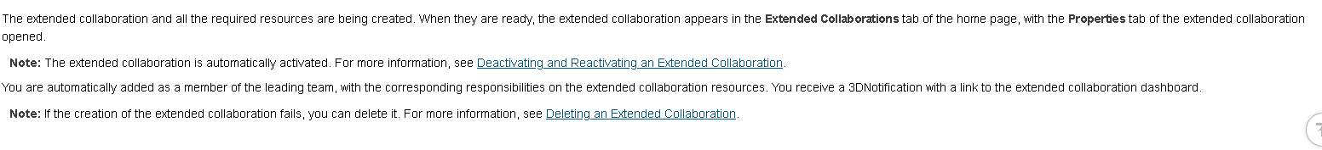

Conclusion: The system is able to identify and retrieve the correct document. However, it fails to retrieve complete and relevant content for the given query.
- The resultant documentation contains 9 steps, to create an extended collaboration but only first 5 steps are retrieved
- Steps 6–9 are missing, leading to incomplete retrieval.

